--1. READING THE PLAN
--1.1 TASK 1 – TABLE WITHOUT INDEX
--Task Result: Read the plan and describe what happened and why with screenshots where needed.
--Check the difference between plans of EXPLAIN, EXPLAIN ANALYZE and EXPLAIN (ANALYZE,
--BUFFERS) command.
--1. Create table test_index:
CREATE TABLE labs.test_index_plan (
num float NOT NULL,
load_date timestamptz NOT NULL
);
--2. Fill the table with a lot of test data:
INSERT INTO labs.test_index_plan(num, load_date)
SELECT random(), x
FROM generate_series('2017-01-01 0:00'::timestamptz,
'2021-12-31 23:59:59'::timestamptz, '10 seconds'::interval) x;
--3. Check the plan of the select (twice at least, is any difference in plans?). Disable the
--parallel query planning If it needed:
SET max_parallel_workers_per_gather = 0;
EXPLAIN ANALYZE SELECT *
FROM labs.test_index_plan
WHERE load_date BETWEEN '2021-09-01 0:00' AND '2021-10-31
11:59:59'
ORDER BY 1;

EXPLAIN 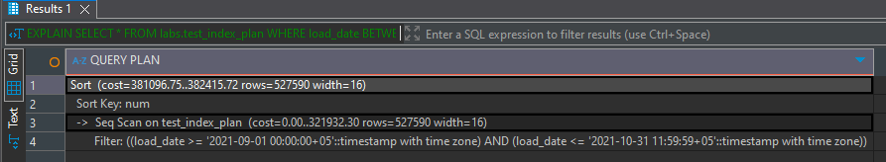
EXPLAIN ANALYZE
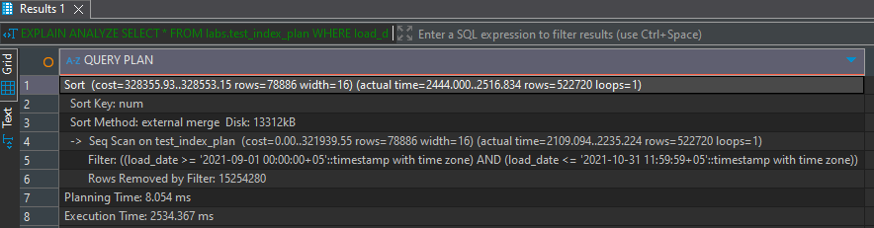
Between first and second big difference in Planning time cause the cache from 1st explain analyze was saved
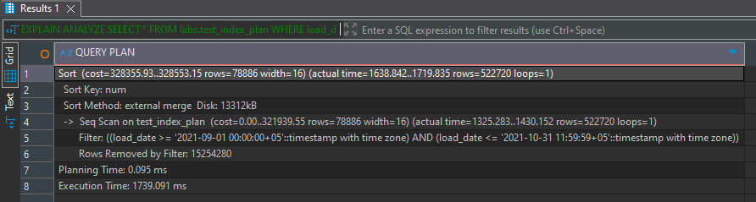
Explain (analyze, buffers)
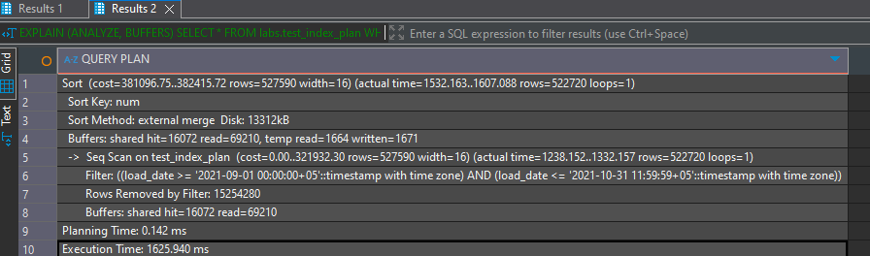
Here we can see additional information in Buffers shared hit=16072 and read 69210
Hit from cache and read from disk, and in first run nothing was saved in buffers
1.2 TASK 2 – ADDING INDEX
Task Result: Read the plan and describe what happened and why with screenshots where needed.
Check the difference between plans of EXPLAIN, EXPLAIN ANALYZE and EXPLAIN (ANALYZE,
BUFFERS) command.
1. Create B-Tree Index on test_index_plan table for load_date column.
2. Check the plan of the select (twice at least, is any difference in plans?). Disable the
parallel query planning If it needed:
SET max_parallel_workers_per_gather = 0;
SELECT *
FROM labs.test_index_plan
WHERE load_date BETWEEN '2021-09-01 0:00' AND '2021-10-31
11:59:59'
ORDER BY 1;
EXPLAIN
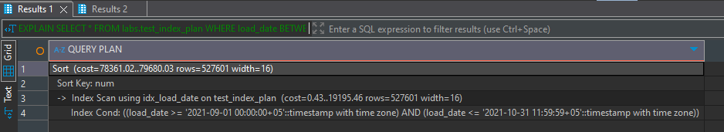
EXPLAIN ANALYZE
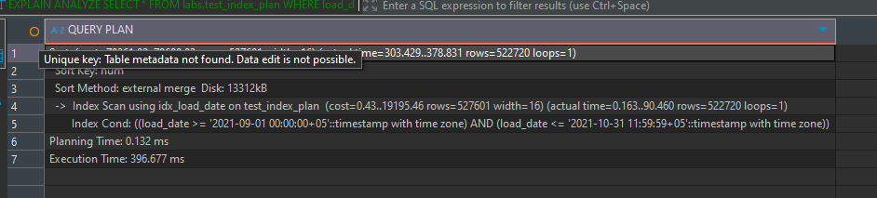
EXPLAIN (ANALYZE, BUFFERS)
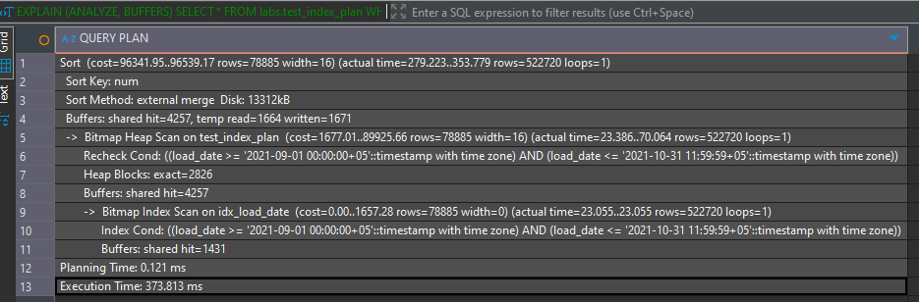
3. What can be done to query to use INDEX ONLY SCAN method?
EXPLAIN (ANALYZE, BUFFERS) SELECT load_date
FROM labs.test_index_plan
WHERE load_date BETWEEN '2021-09-01 0:00' AND '2021-10-31
11:59:59'
ORDER BY 1;
Change * to load_date the colum on which index was done.

4. DROP B-tree Index from test_index_plan table and create BRIN index on test_index_plan
table for load_date column. Check the plan of the select (twice at least, is any difference
in plans?).
SELECT *
FROM labs.test_index_plan
WHERE load_date BETWEEN '2021-09-01 0:00' AND '2021-10-31
11:59:59'
ORDER BY 1;
EXPLAIN
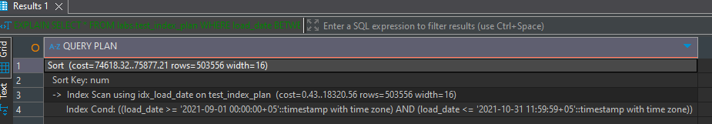
EXPLAIN ANALYZE
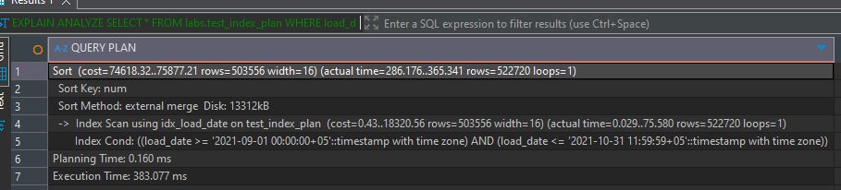
EXPLAIN ANALYZE BUFFERS
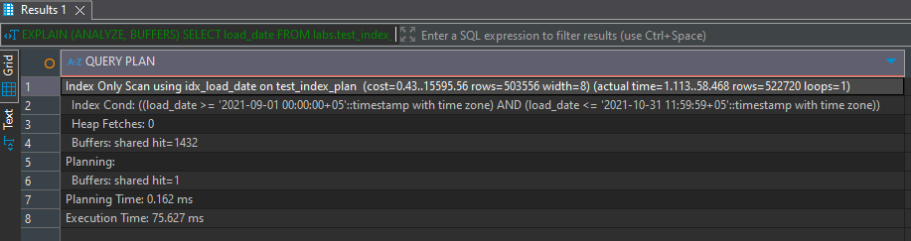

--2. ADDING DATA WITH INSERT AND COPY
--2.1 TASK 3 BULK INSERT
--Task Result: Provide queries where needed. Describe what happened and why with screenshots where
--needed.
--1. Create new table:
CREATE TABLE labs.test_inserts (
num float NOT NULL,
load_date timestamptz NOT NULL
);
--2. Add B-Tree index on the table test_inserts on load_date column.
CREATE INDEX IF NOT EXISTS idx_test_inserts_btree ON labs.test_inserts (load_date);
--3. INSERT into test_inserts by using:
INSERT INTO labs.test_inserts
SELECT num, load_date
FROM labs.test_index_plan;
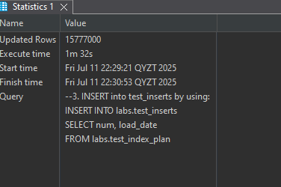
Inserting into a table with an index takes longer time because PostgreSQL has to update the index for each inserted row.
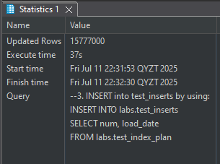 Without index
--4. Create new table*:
CREATE TABLE emp (
empno NUMERIC(4) NOT NULL CONSTRAINT emp_pk PRIMARY KEY,
ename VARCHAR(10) UNIQUE,
job VARCHAR(9),
mgr NUMERIC(4),
hiredate DATE
);
--5. Rewrite INSERT statements to more efficient way, run it:
INSERT INTO emp VALUES (1,'SMITH','CLERK',13,'17-DEC-80');
INSERT INTO emp VALUES (2,'ALLEN','SALESMAN',6,'20-FEB-81');
INSERT INTO emp VALUES (3,'WARD','SALESMAN',6,'22-FEB-81');
INSERT INTO emp VALUES (4,'JONES','MANAGER',9,'02-APR-81');
INSERT INTO emp VALUES (5,'MARTIN','SALESMAN',6,'28-SEP-81');
INSERT INTO emp VALUES (6,'BLAKE','MANAGER',9,'01-MAY-81');
INSERT INTO emp VALUES (7,'CLARK','MANAGER',9,'09-JUN-81');
INSERT INTO emp VALUES (8,'SCOTT','ANALYST',4,'19-APR-87');
INSERT INTO emp VALUES (9,'KING','PRESIDENT',NULL,'17-NOV-81');
INSERT INTO emp VALUES (10,'TURNER','SALESMAN',6,'08-SEP-81');
INSERT INTO emp VALUES (11,'ADAMS','CLERK',8,'23-MAY-87');
INSERT INTO emp VALUES (12,'JAMES','CLERK',6,'03-DEC-81');
INSERT INTO emp VALUES (13,'FORD','ANALYST',4,'03-DEC-81');
INSERT INTO emp VALUES (14,'MILLER','CLERK',7,'23-JAN-82');
--*please do not delete emp table after this module
I rewrite insert as 1 query, so now it is more efficient.
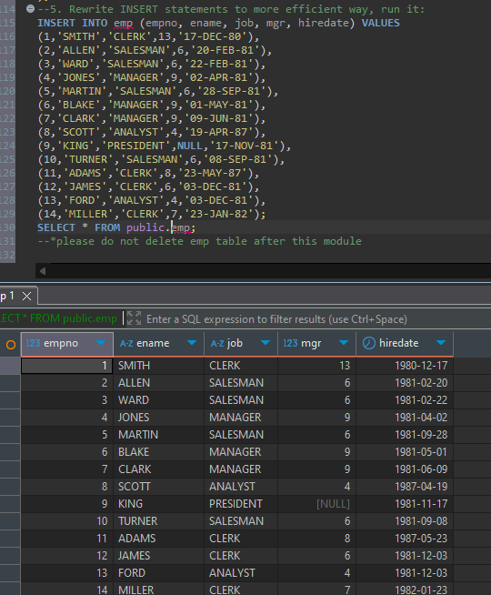

--2.2 TASK 4 COPY COMMAND
--Task Result: Provide queries where needed. Describe what happened and why with screenshots where
--needed.
--1. Use COPY Command to export your test_index_plan table into csv file:
COPY labs.test_index_plan TO
'C:\Program Files\PostgreSQL\17\data\test_index_plan.csv' DELIMITER ',' CSV HEADER;

--Change command to export column load_date from test_index_plan with quotes and num
--column without quotes.
COPY (SELECT num, '"' || load_date || '"' AS load_date FROM labs.test_index_plan)
TO 'C:\Program Files\PostgreSQL\17\data\test_index_plan_formatted.csv' DELIMITER ',' CSV HEADER;

--2. Use COPY to export data from test_index_plan table into csv file ‘test_index_plan_short.csv’
--where load_date between '2021-09-01 0:00' AND '2021-09-01 11:59:59'
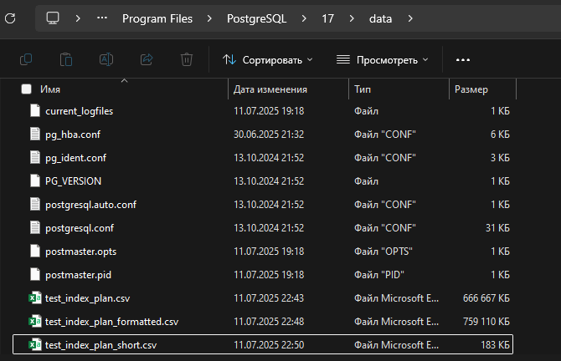
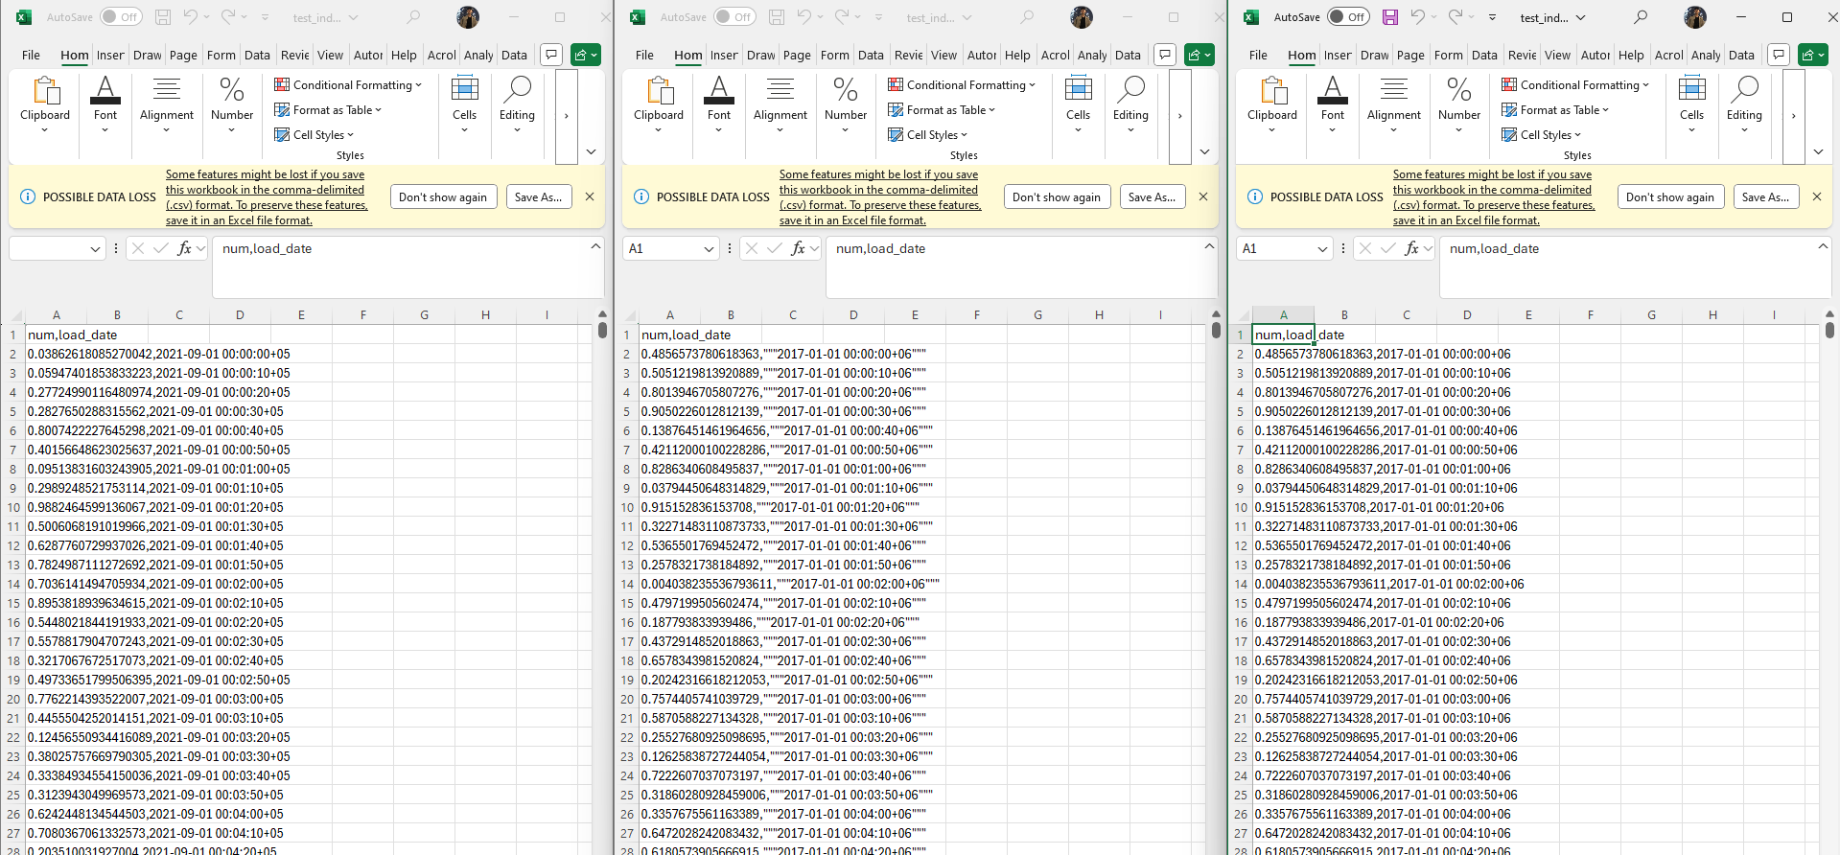
--3. Create new table:
CREATE TABLE labs.test_copy (
num float NOT NULL,
load_date timestamptz NOT NULL
);
--4. Add B-Tree index on the table test_inserts on load_date column.
CREATE INDEX IF NOT EXISTS idx_test_copy_btree ON labs.test_copy (load_date);
--5. COPY into test_copy by using test_index_plan.csv file.
COPY labs.test_copy FROM
'C:\Program Files\PostgreSQL\17\data\test_index_plan.csv' DELIMITER ',' CSV HEADER;
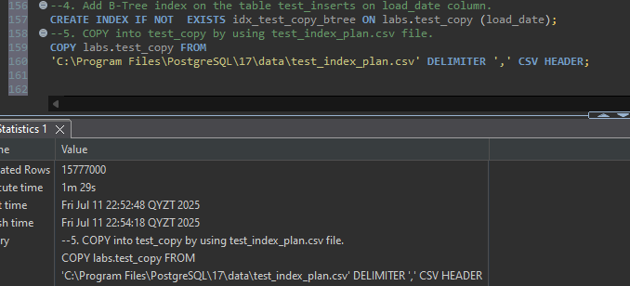
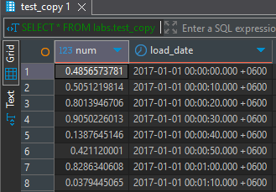

--2.3 TASK 5 UPSERT
--Task Result: Provide queries where needed. Describe what happened and why with screenshots where
--needed.
--1. Add into emp table following information in one UPSERT statement:

